Theory background

**PT 100 Resistance Temperature Detector (RTD)**

1. RTD

An RTD (Resistance Temperature Detector) is a sensor whose resistance changes as its temperature changes. The resistance increases as the temperature of the sensor increases. The resistance vs temperature relationship is well known and is repeatable over time. An RTD is a passive device. It does not produce an output on its own. External electronic devices are used to measure the resistance of the sensor by passing a small electrical current through the sensor to generate a voltage. Typically 1 mA or less measuring current, 5 mA maximum without the risk of self-heating.[1]

1. PT 100 RTD

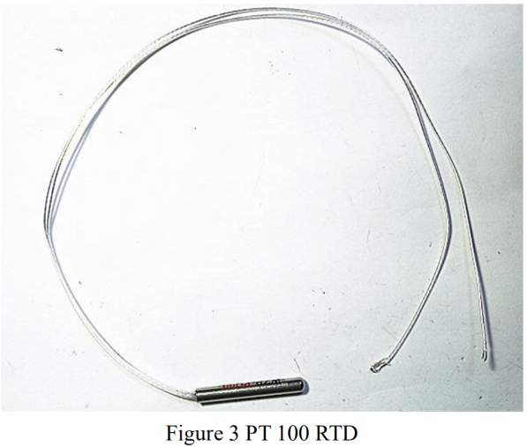

The pt100 is one of the most accurate temperature sensors. Not only does it provide good accuracy, it also provides excellent stability and repeatability. Most OMEGA standard pt100 comply with DIN-IEC Class B. Pt100 are also relatively immune to electrical noise and therefore well suited for temperature measurement in industrial environments, especially around motors, generators and other high voltage equipment.[2]

1. Theory equation for the temperature

The PT 100 RTD has an impedance of 100 Ω at 0°C and roughly 0.385 Ω of resistance change per 1°C change in temperature. The resistance is 18.51 Ω at -200°C and 390.48 Ω at 850°C.

So the relationship between temperature and resistance is below

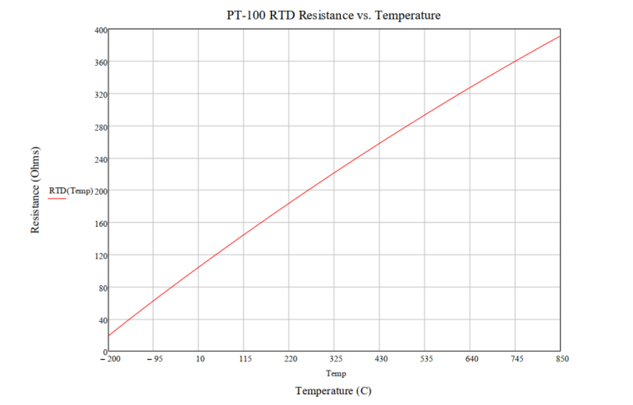

**Infrared Photoelectric Sensor**

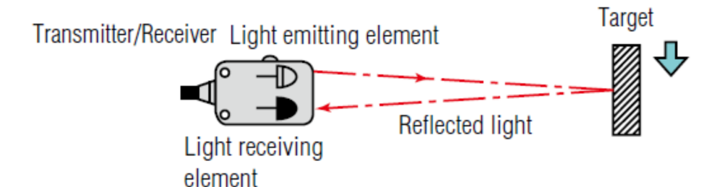[2]

The fundamental principles is shown in the figure

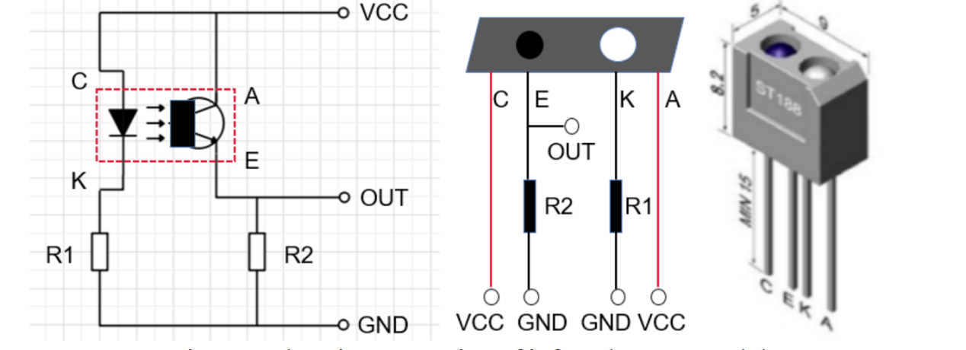

Ususally we set, R1 = 510 Ω, R2 = 25K Ω, to limit the current. White matter absorbs less light and most light waves are reflected; black matter can absorb most light waves and only part of them are reflected.

**Triode (Transistors)**

A triode is an electronic amplifying vacuum tube (or valve in British English) consisting of three electrodes inside an evacuated glass envelope: a heated filament or cathode, a grid, and a plate (anode). ... Its invention founded the electronics age, making possible amplified radio technology and long-distance telephony. [3]

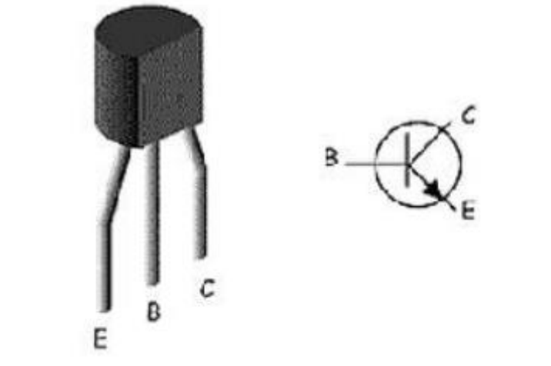

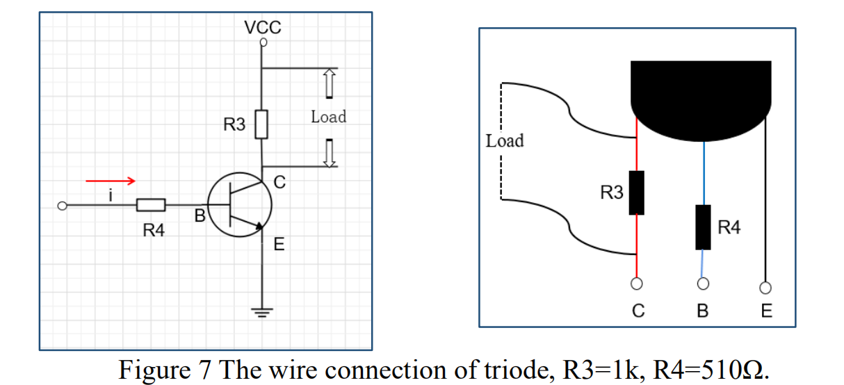

the change of the collector current is β times of the change of the base current, that is, the current change is amplified by β times, If we add a changing small signal between the base and emitter, it will cause a change in the base current . After the change is amplified, it leads to a big change . If the collector current Ic flows through a resistor R, according to the voltage calculation formula U = R * I, the voltage on the resistor will change greatly. We take out the voltage on the resistor and get the amplified voltage signal.[4]

**Pulse-Width Modulation (PWM) Signal Generation**

The wave graph is shown here:





In the case of the Elvis III workbench, the maximum voltage Vmax is 5 V and the minimum voltage Vmin is 0 V. Thus, the average motor voltage is:



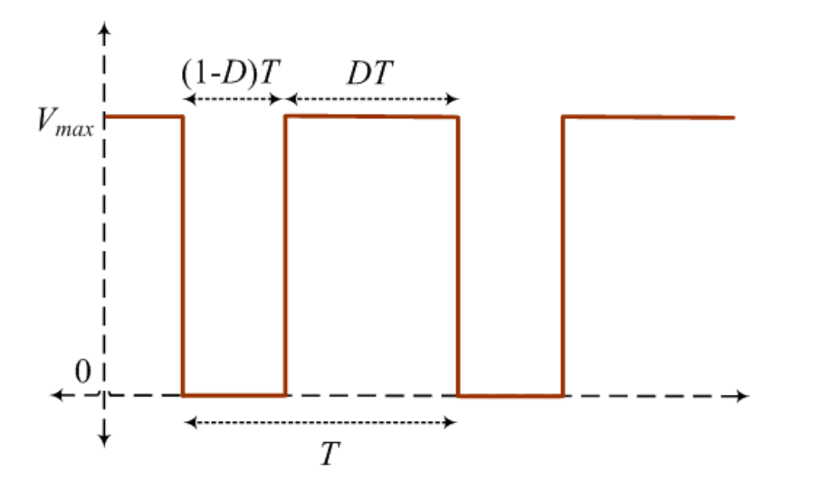

**The code theory**

if/else statement

Executes a block of statements if the specified condition is true; otherwise, the block of statements in the else clause are executed.

Apps usually need to make decisions and execute some code if something is true and some other code otherwise. Most programming languages have an if/else statement: to check to see if some expression is true, and if it is do something, otherwise do something else.

An if/else statement requires you to define an expression that evaluates to true or false. Just as in arithmetic there are some operators you can use to write expressions that evaluate to a number, programming languages also have a comparison operators (< <= == > >= !=) and boolean operators (&& || !) that let you write expressions that evaluate to true or false.

The if/else statement defines two blocks of code to execute between open and closing curly braces {}. If the condition is true then the block of code inside the first curly braces is executed from top to bottom, exactly once. If the condition is false then then the block of code inside the second curly braces is executed from top to bottom, exactly once. [5]

**References:**

[1]. https://www.te.com/usa-en/industries/sensor-solutions/insights/understanding-rtds.html

[2]. <https://www.omega.com/en-us/resources/rtd-hub>

1. <https://en.wikipedia.org/wiki/Triode>
2. Luqi. Project
3. https://studio.code.org/docs/applab/ifElseBlock/